

**Misr University for Science & Technology**

**College of Information Technology  
Information Systems Department**

**IS312 (Intro. to Database)  
Project Title: Airline Booking System(P.No.#8)**

**Team Members**

|  |  |
| --- | --- |
| **Student Name** | **ID** |
| Mohamed Ayman | 200026500 |
| Rabab Mohsen | 200019725 |
| Belal Ahmed Saqer | 200023029 |
| Omar Ahmed Asaad | 200027710 |
| Assem Mohamed | 200030013 |
| Rawan Mohamed Mahmoud | 200031284 |
| Ahmed Gwayed | 200027755 |

**Supervised by:**

**Dr/ Alaa Eldein Yassin**   
**Assistant Lecturer/ Ayman S. Abdelaziz  
T.A/ Amany Mohamed**

**Spring/2025**

**Phase (I): Database Design   
a) ER Diagram**

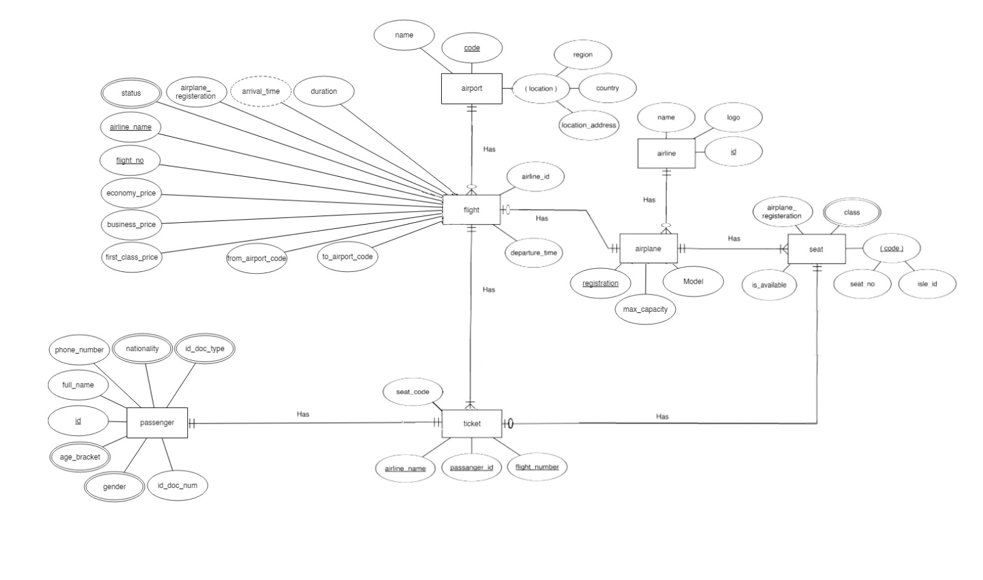

**Phase (I): Database Design**  
**b) Schema**   
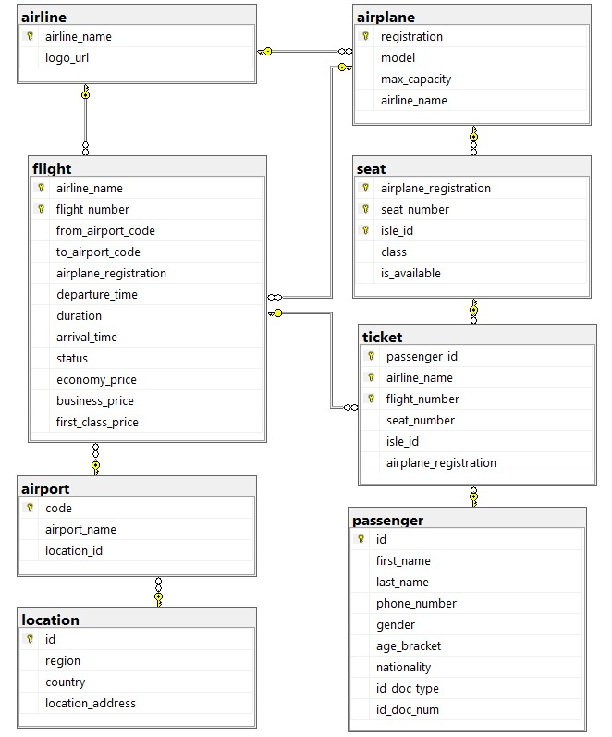

**Phase (II): Database Implementation**

**1- Create Database**

|  |
| --- |
| **SQL Statement** |
| CREATE DATABASE airline_reservation_system; |

**2- USE Database**

|  |
| --- |
| **SQL Statement** |
| USE airline_reservation_system; |

**3- Create tables: (For Each Entity)**

|  |
| --- |
| **SQL Statements** |
| CREATE TABLE passenger (  id INT IDENTITY(1,1) PRIMARY KEY,  first_name VARCHAR(30) NOT NULL,  last_name VARCHAR(30) NOT NULL,  title VARCHAR(30) NOT NULL,  phone_number VARCHAR(15) NOT NULL  CHECK (  phone_number NOT LIKE '%[^0-9]%'  AND LEN(phone_number) BETWEEN 7 AND 15  ),  gender VARCHAR(9) CHECK (gender IN ('Male', 'Female')) NOT NULL, -- enum (multivalued)  age_bracket VARCHAR(6) CHECK (age_bracket IN ('Infant', 'Child', 'Adult')) NOT NULL,  nationality VARCHAR(30) NOT NULL,  id_doc_type VARCHAR(20) CHECK (id_doc_type IN ('Driver License', 'Passport', 'National ID')) NOT NULL,  id_doc_num SMALLINT NOT NULL,);  CREATE TABLE location( --composite attr8 in erd  id INT IDENTITY(1,1) PRIMARY KEY,  region VARCHAR(30) NOT NULL,  country VARCHAR(30) NOT NULL,  location_address VARCHAR(255)  );  CREATE TABLE airport (  code CHAR(3) PRIMARY KEY,  airport_name VARCHAR(60) NOT NULL,  location_id INT NOT NULL,  FOREIGN KEY (location_id) REFERENCES location(id)  );  CREATE TABLE airline (  id INT IDENTITY(1,1) PRIMARY KEY,  airline_name VARCHAR(40) NOT NULL,  logo_url VARCHAR(512)  );  CREATE TABLE airplane (  id INT IDENTITY(1,1) PRIMARY KEY,  model VARCHAR(40),  max_capacity INT NOT NULL,  airline_id INT NOT NULL,  FOREIGN KEY (airline_id) REFERENCES airline(id)  );  CREATE TABLE seat (  airplane_id INT NOT NULL,  seat_number INT NOT NULL,  isle_id CHAR(1) NOT NULL,  class VARCHAR(10) CHECK (class IN ('Economy', 'Business')),  is_available BIT NOT NULL DEFAULT 1, -- 1 = available, 0 = not available  PRIMARY KEY (seat_number, isle_id),  FOREIGN KEY (airplane_id) REFERENCES airplane(id)  );  CREATE TABLE flight (  id INT IDENTITY(1,1) PRIMARY KEY,  from_airport_code CHAR(3) NOT NULL,  to_airport_code CHAR(3) NOT NULL,  airline_id INT NOT NULL,  airplane_id INT NOT NULL,  departure_time DATETIME NOT NULL,  duration INT NOT NULL, -- in minutes  arrival_time AS DATEADD(MINUTE, duration, departure_time) PERSISTED,  status VARCHAR(10) CHECK (status IN ('On Time', 'Delayed', 'Cancelled')),  FOREIGN KEY (from_airport_code) REFERENCES airport(code),  FOREIGN KEY (to_airport_code) REFERENCES airport(code),  FOREIGN KEY (airline_id) REFERENCES airline(id),  FOREIGN KEY (airplane_id) REFERENCES airplane(id)  );  CREATE TABLE ticket (  price SMALLINT NOT NULL,  passenger_id INT NOT NULL,  flight_id INT NOT NULL,  seat_number INT NOT NULL,  isle_id CHAR(1) NOT NULL,  FOREIGN KEY (seat_number, isle_id) REFERENCES seat(seat_number, isle_id),  FOREIGN KEY (passenger_id) REFERENCES passenger(id),  FOREIGN KEY (flight_id) REFERENCES flight(id),  PRIMARY KEY (seat_number, isle_id, passenger_id, flight_id)  ); |

**4- Data Insertion:- (at least 3 records for each table)**

|  |
| --- |
| **SQL Statements** |
| INSERT INTO location (region, country, location_address) VALUES  ('Cairo', 'Egypt', 'Oruba Road, Heliopolis'),  ('New York', 'USA', 'Jamaica, NY 11430'),  ('New York', 'USA', '9400 Ditmars Blvd, East Elmhurst, NY 11369'),  ('Los Angeles', 'USA', '1 World Way, Los Angeles, CA 90045'),  ('Chicago', 'USA', '10000 W O''Hare Ave, Chicago, IL 60666'),  ('San Francisco', 'USA', 'San Francisco, CA 94128'),  ('Miami', 'USA', '2100 NW 42nd Ave, Miami, FL 33142'),  ('London', 'UK', 'Longford TW6'),  ('Paris', 'France', '95700 Roissy-en-France'),  ('Tokyo', 'Japan', 'Narita, Chiba 282-0004'),  ('Dubai', 'UAE', 'Dubai, UAE'),  ('Sydney', 'Australia', 'Mascot NSW 2020, Australia'),  ('Singapore', 'Singapore', 'Airport Boulevard, Singapore 819643'),  ('Toronto', 'Canada', '6301 Silver Dart Drive, Mississauga');  INSERT INTO airport (code, airport_name, location_id) VALUES  ('CAI', 'Cairo International Airport', (SELECT id FROM location WHERE location_address = 'Oruba Road, Heliopolis')),  ('JFK', 'John F. Kennedy International Airport', (SELECT id FROM location WHERE location_address = 'Jamaica, NY 11430')),  ('LGA', 'LaGuardia Airport', (SELECT id FROM location WHERE location_address = '9400 Ditmars Blvd, East Elmhurst, NY 11369')),  ('LAX', 'Los Angeles International Airport', (SELECT id FROM location WHERE location_address = '1 World Way, Los Angeles, CA 90045')),  ('ORD', 'O''Hare International Airport', (SELECT id FROM location WHERE location_address = '10000 W O''Hare Ave, Chicago, IL 60666')),  ('SFO', 'San Francisco International Airport', (SELECT id FROM location WHERE location_address = 'San Francisco, CA 94128')),  ('MIA', 'Miami International Airport', (SELECT id FROM location WHERE location_address = '2100 NW 42nd Ave, Miami, FL 33142')),  ('LHR', 'Heathrow Airport', (SELECT id FROM location WHERE location_address = 'Longford TW6')),  ('CDG', 'Charles de Gaulle Airport', (SELECT id FROM location WHERE location_address = '95700 Roissy-en-France')),  ('NRT', 'Narita International Airport', (SELECT id FROM location WHERE location_address = 'Narita, Chiba 282-0004')),  ('DXB', 'Dubai International Airport', (SELECT id FROM location WHERE location_address = 'Dubai, UAE')),  ('SYD', 'Sydney Kingsford Smith Airport', (SELECT id FROM location WHERE location_address = 'Mascot NSW 2020, Australia')),  ('SIN', 'Singapore Changi Airport', (SELECT id FROM location WHERE location_address = 'Airport Boulevard, Singapore 819643')),  ('YYZ', 'Toronto Pearson International Airport', (SELECT id FROM location WHERE location_address = '6301 Silver Dart Drive, Mississauga'));  INSERT INTO airline (airline_name, logo_url) VALUES  ('SkyJet', 'https://example.com/logo/skyjet.png'),  ('CloudAir', 'https://example.com/logo/cloudair.png'),  ('GlobalFly', 'https://example.com/logo/globalfly.png');  INSERT INTO airplane (model, max_capacity, airline_id) VALUES  ('Boeing 737', 180, 1),  ('Airbus A380', 500, 2),  ('Boeing 777', 300, 3);  INSERT INTO seat (airplane_id, seat_number, isle_id, class, is_available) VALUES  (1, 1, 'A', 'Economy', 1),  (1, 2, 'B', 'Economy', 1),  (1, 3, 'C', 'Business', 1),  (1, 4, 'D', 'Economy', 1);  INSERT INTO passenger (first_name, last_name, phone_number, gender, age_bracket, nationality) VALUES  ('Alice', 'Johnson', '1234567890', 'Female', 'Adult', NULL),  ('Bob', 'Smith', '2345678901', 'Male', 'Adult', NULL),  ('Cecilia', 'Tanaka', '3456789012', 'Female', 'Adult', 'Japan'),  ('David', 'Nguyen', '4567890123', 'Male', 'Child', 'Vietnam'),  ('Elena', 'Garcia', '5678901234', 'Female', 'Adult', 'Brazil'),  ('Farouk', 'Hassan', '6789012345', 'Male', 'Adult', NULL),  ('Grace', 'Lee', '7890123456', 'Female', 'Infant', 'South Korea'),  ('James', 'Brown', '8901234567', 'Male', 'Adult', 'UK'),  ('jane', 'austin', '19071734214', 'Female', 'Adult', 'USA'),  ('jacob', 'smith', '8201564667', 'Male', 'Adult', 'South Africa');  INSERT INTO flight (from_airport_code, to_airport_code, airline_id, airplane_id, departure_time, duration, status) VALUES  ('JFK', 'LHR', 1, 1, '2025-04-15 08:00:00', 420, 'On Time'),  ('LHR', 'CAI', 2, 2, '2025-04-16 09:30:00', 720, 'Delayed'),  ('DXB', 'YYZ', 3, 3, '2025-04-17 23:00:00', 960, 'Cancelled'),  ('SFO', 'JFK', 1, 1, '2025-04-18 06:00:00', 840, 'On Time'),  ('NRT', 'DXB', 2, 2, '2025-04-19 21:00:00', 540, 'On Time');  INSERT INTO ticket (passenger_id, flight_id, seat_number, isle_id) VALUES  (1, 1, 1, 'A'),  (2, 1, 2, 'B'),  (3, 2, 3, 'C'),  (4, 2, 4, 'D'); |

**5- UPDATE**

|  |
| --- |
| **SQL Statement** |
| UPDATE flight  SET status = 'Cancelled'  WHERE id = 2; |

**6- DELETE**

|  |
| --- |
| **SQL Statement** |
| DELETE FROM passanger  WHERE name = 'Alice' AND last_name = 'Johnson'; |

**7- Select statements (Only 7 Statements and their output)  
  
7.1) Using LIKE Operator**

|  |
| --- |
| **SQL Statement** |
| SELEECT * from passenger  WHERE first_name LiKE 'J_%'; |
| **Output (Screen Shot)** |
|  |

**7.2) Using IN Operator**

|  |
| --- |
| **SQL Statement** |
| SELECT * from passenger  WHERE id IN (1, 5); |
| **Output (Screen Shot)** |
|  |

**7.3) Using Between Operator**

|  |
| --- |
| **SQL Statement** |
| SELECT * FROM flight  WHERE departure_time BETWEEN '2025-04-17 23:00:00' AND '2025-04-19 21:00:00'; |
| **Output (Screen Shot)** |
|  |

**7.4) Using IS NULL Operator**

|  |
| --- |
| **SQL Statement** |
| SELECT * FROM passenger  WHERE nationality IS NULL; |
| **Output (Screen Shot)** |
|  |

**7.5) Using IS NOT NULL Operator**

|  |
| --- |
| **SQL Statement** |
| SELECT * FROM passenger  WHERE nationality IS NOT NULL; |
| **Output (Screen Shot)** |
|  |

**7.6) Using Distinct Keyword**

|  |
| --- |
| **SQL Statement** |
| SELECT DISTINCT class from seat; |
| **Output (Screen Shot)** |
|  |

**7.7) Using TOP Clause**

|  |
| --- |
| **SQL Statement** |
| SELECT TOP 2 *  FROM flight; |
| **Output (Screen Shot)** |
|  |

**8- Data Sorting**

|  |
| --- |
| **SQL Statement** |
| SELECT * FROM passenger  ORDER BY first_name DESC, last_name; |
| **Output (Screen Shot)** |
|  |

**9- Data Grouping**

|  |
| --- |
| **SQL Statement** |
| SELECT age_bracket, COUNT(*) AS number_of_passengers  FROM passenger  GROUP BY age_bracket; |
| **Output (Screen Shot)** |
|  |

**10- Creating Index**

|  |
| --- |
| **SQL Statement** |
| **CREATE INDEX idx_airport**  **ON airport (code, airport_name);** |

**11- Creating View**

|  |
| --- |
| **SQL Statement** |
| CREATE VIEW Traveller AS  SELECT id, first_name, last_name , title  FROM passenger  WHERE first_name IS NOT NULL; |

**12- Creating Sub-Query**

|  |
| --- |
| **SQL Statement** |
| SELECT first_name, last_name, phone_number  FROM passenger  WHERE id IN (  SELECT passenger_id  FROM ticket  WHERE flight_id IN (  SELECT id  FROM flight  WHERE from_airport_code = 'JFK' AND to_airport_code = 'LHR'  )  ); |

**Phase (III): GUI**  
  
**Form (I) Screen Shot**  
  
  
  
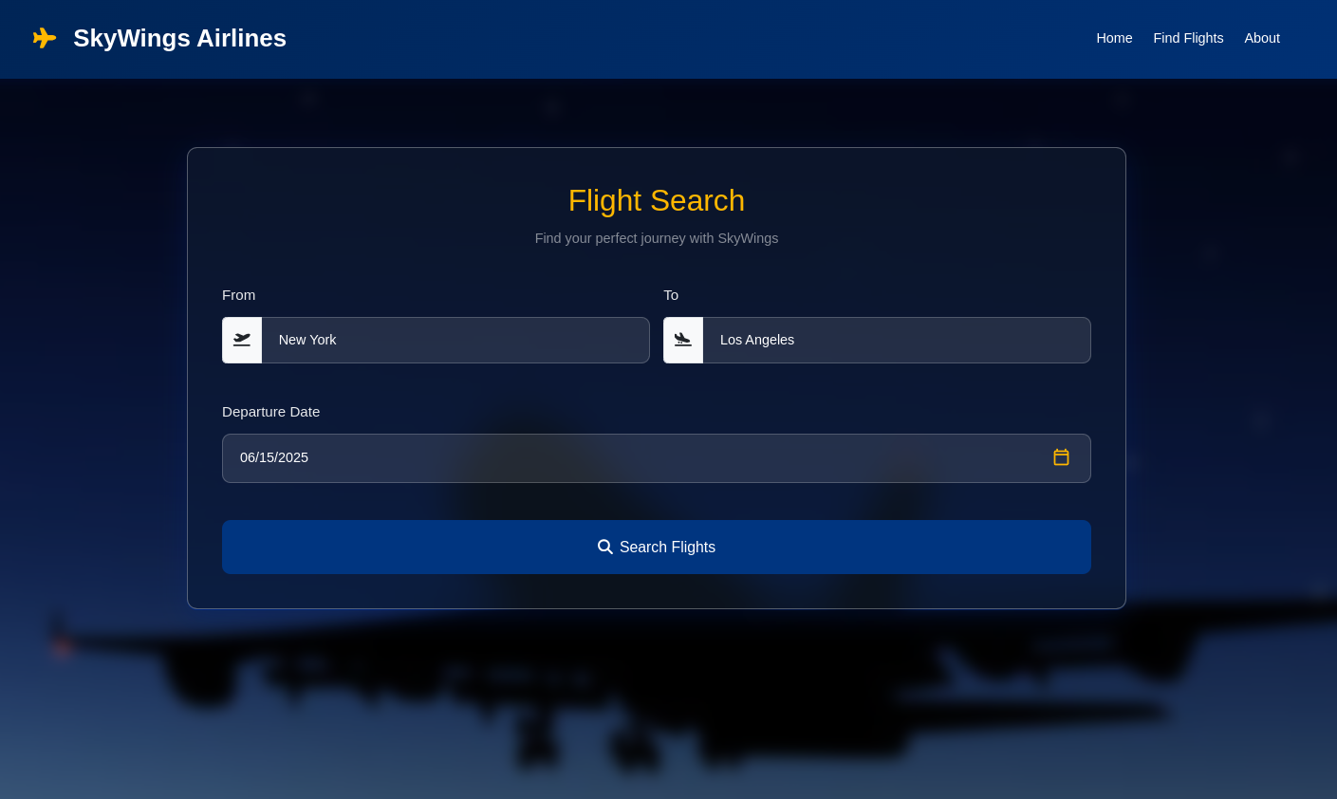

**Form (II) Screen Shot**  
  
  
  
  
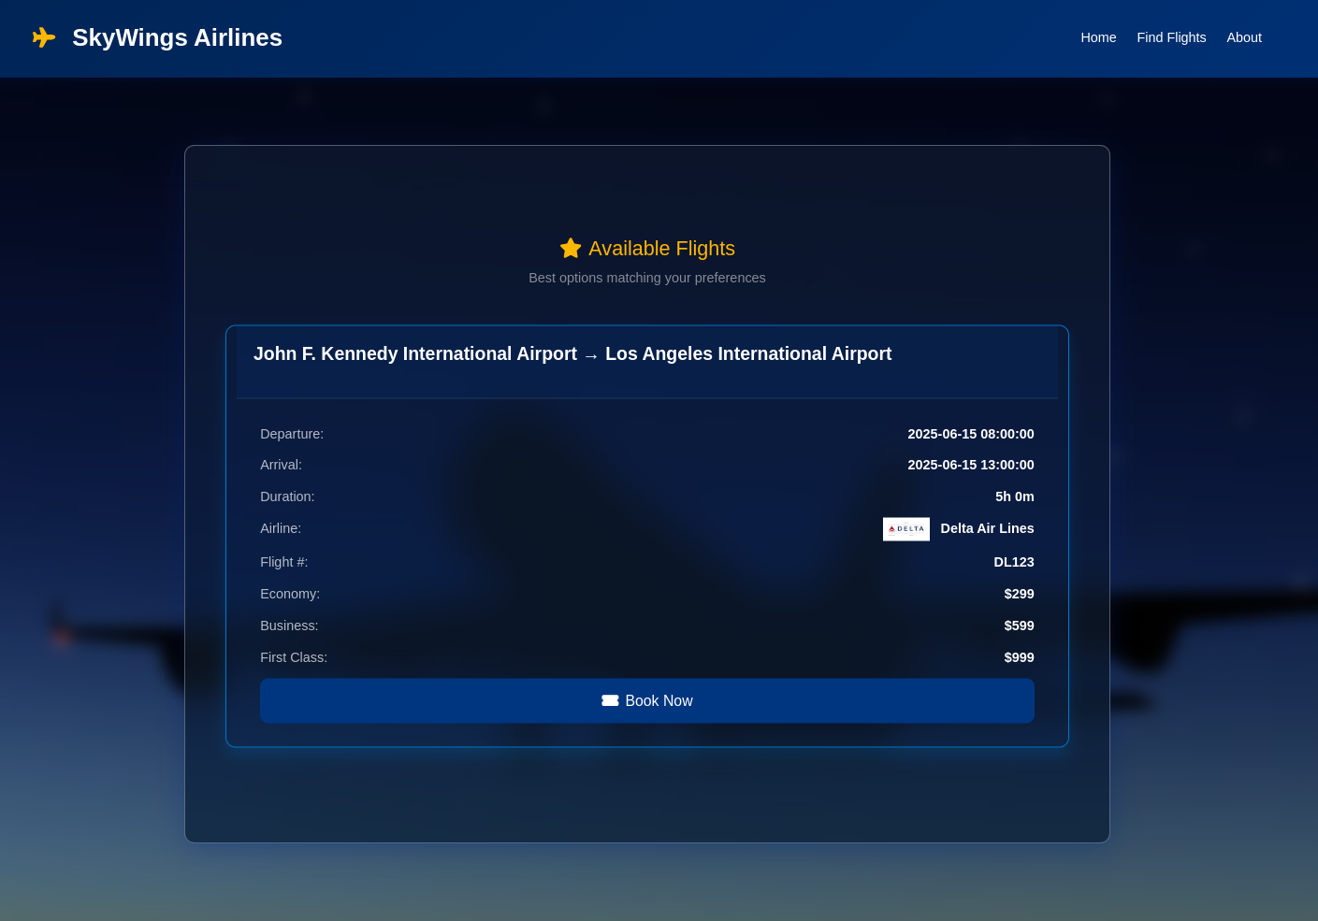

**Form (III) Screen Shot**

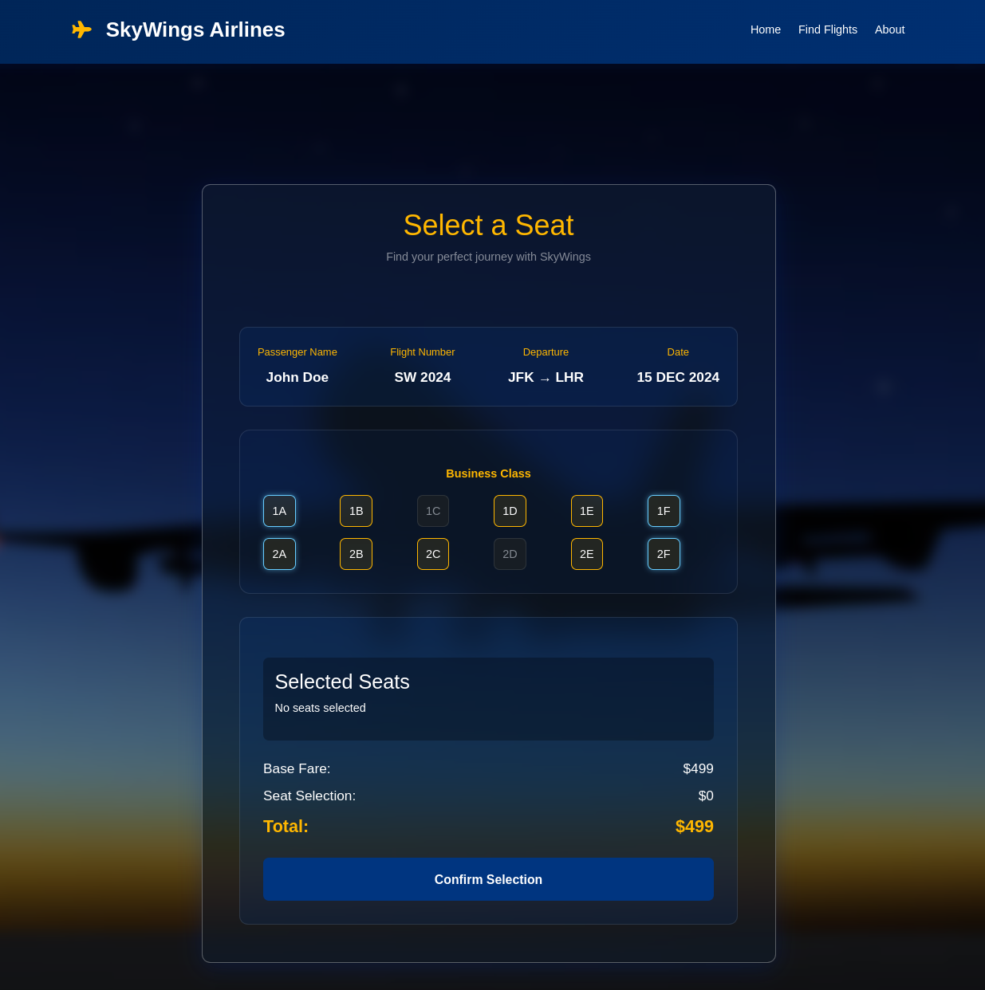

**Form (IV) Screen Shot**

